(Approx. 735 words)

Helpful Memory Bytes
By Jim Cerny, Forums Coordinator / Instructor, Sarasota Technology Users Group
www.thestug.org
vp1 (at) thestug.org

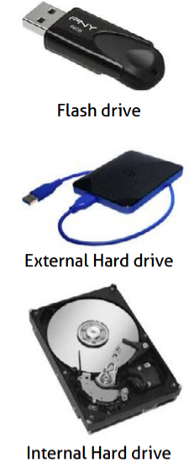
Let’s review and explore what we need to know about basic computer storage (bits and bytes) and how it helps us get an idea of the data space
needed to save and backup our stuff.

Suppose you landed on a planet, and the aliens there only had one hand and
one finger on it (not ten fingers like we do). All they could do was flash a
single digit or none at all (hence, a zero or one). How high could they count?
Could they do basic math?

All computers use the binary system (a single digit of 1 or 0) – that is, they store and work with data saved in memory as zeros and ones. But there is NO LIMIT to how high you can count – you keep adding on more zeros and ones. For example, the digits we know in our numbering system such as 1, 2,
3, 4, 5, 6, 7, 8, 15, 16, 31, 32, 33, etc. would be the following in binary = 1, 10, 11, 100, 101, 110, 111, 1000, 1111, 10000, 11111, 100000, 100001, etc. So, adding a new digit to the left doubles the size of the memory (or number). Believe it or not, math gets a lot simpler with only two digits.

A single binary digit is called a BIT. Eight bits together form a BYTE of data.
Eight bits allow for 256 different combinations, enough to cover not only our
26-character alphabet, but special characters and more. Every keystroke on
your keyboard enters one byte into memory!

I love the old science fiction movies – where the spacecraft command center was filled with gauges and dials! To read a value on a dial, you had to look closely to see where the arrow was. It showed measurement on a scale of lines, and it was up to you and your eyesight to see the amount or “reading.” But with binary digits, you don’t care about “how much”; you only need to know if it is there or not there -- a one or a zero. To get more accuracy, you add more binary digits. So, you will need a lot of them, but
they are cheap and much easier for use in electronics.

One KILO-byte of memory is 1024 bytes, but when we start dealing with large amounts of computer storage, we round it off and call it a thousand.

One MEGA-byte of data is one million bytes or one thousand kilobytes. Those old 3.5-inch computer disks (remember them?) held about one and a half megabytes or about 220 pages of text. A CD-ROM (computer disk) could hold about 700 megabytes, that’s over 400 of those old floppy disks and approximately 90,000 pages of text. It is good to remember that photos, depending upon the number of pixels in them, can be from 10 or 20 kilobytes up to 2, 12, 24, or more megabytes each! So, is a picture worth a thousand words? You bet, and more!

One GIGA-byte is one trillion bytes or one-thousand megabytes. Now we are talking serious (and very inexpensive) memory! You can buy a small portable USB drive (called a “thumb” drive or “flash” drive) in various gigabyte sizes – I tend to like the 32 or 64-gigabyte size because it can easily hold all my photos and documents as my backup. Just one gigabyte can hold almost 700,000 pages of text. That’s a den full of books. One HD (high-definition) movie can take 2 to 5 gigabytes of memory. Movies and videos are moving pictures, of course, several pictures (or “frames”) per second. Fortunately, the data used to store photos and movies are “compressed” or coded to take up much less space than you would expect.

One TERA-byte is one thousand gigabytes. For us ordinary people, this is a HUGE amount of memory! You can get a one-terabyte drive for about $50. It can hold 300,000 photos or about 500 hours of movies. And, unlike my memory, it will never forget anything.

The next memory size up is the PETA-byte -- yup, one-thousand terabytes! And, no, they are not going to run out of prefixes. All just to store ones and zeros.

I use a nice little thumb drive to back up my memory, but I seem to forget where I put it!

